What are the graded items for this course and how much does each of them count?

The auto-graded mmt homework makes up 200 point collectively. There are 4 test of 100 point and a final test of 200 points. The in class quizzes are 20 points each. There are journal entries worth between 5 and 7 points with optional additional ones worth 3 points. A proper course binder containing course documents is also inspected and graded.

What is the policy for making up quizzes? Tests?

There is no make-up for quizzes, they are based on class attendance. Make-up test are only available with previous coordination and communication.

Where are most of the homework assignments done?

Mostly on mml but there are also assignments from the book that round out the mml exercises.

What topics are included in the course?

Set theory, logic, geometry, computer history, numeration, sequences and series, truth statements.

What items should be included in your binder?

Syllabus, handouts, journals, tests, quizzes, and lecture notes.

What help and preparation is available for doing homework?

The mml software provides example and allows for questions relevant to a given exercises to be emailed to the instructor. There are also video lectures in the media library as well as power points.

What is the best way to contact me?

Email is the best form of contact.

What primary means do I use to communicate with you outside class?

Announcements on blackboard.

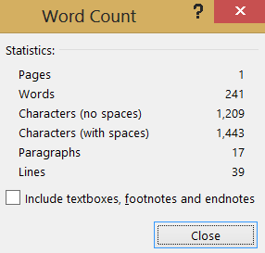**10/26/2013**